

Item Suggestions



- 1 -

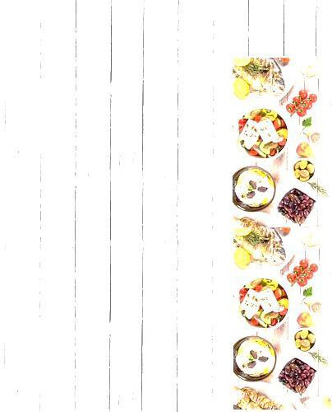BUFFET GRID & COMPOSITION

|  |  |  |  |  |  |  |  |
| --- | --- | --- | --- | --- | --- | --- | --- |
| **Standard Vegetarian Menu (Rs.1499 ++ taxes)** | |  | **Executive Vegetarian Menu (Rs.1699 ++ taxes)** | | | | |
| 1 | WELCOME DRINK | 1 | | | WELCOME DRINK | |
| 2 | SALAD | 3 | | | SALAD | |
| 1 | SOUP | 2 | | | SOUP | |
| 2 | STARTER | 3 | | | STARTER | |
| 2 | MAIN COURSE (no Paneer) | 3 | | | MAIN COURSE (1Paneer) | |
| 1 | DAL | 1 | | | DAL | |
| 1 | FLAVORED RICE | 1 | | | FLAVORED RICE | |
| 1 | STEAMED RICE | 1 | | | STEAMED RICE | |
| 2 | INDIAN BREADS | 2 | | | INDIAN BREADS | |
| 1 | CURD RICE/ CURD | 1 | | | CURD RICE/ CURD | |
| 1 | PICKLE | 1 | | | PICKLE | |
| 1 | PAPAD | 1 | | | PAPAD | |
| 2 | SWEETS/ DESSERTS | 3 | | | SWEETS/ DESSERTS | |
| 1 | ICE CREAM | 1 | | | ICE CREAM | |
|  | | | | | | | |
| **Standard Non - Vegetarian**  **Menu (Rs.1599 ++ taxes)** | | | |  | **Executive Non -Vegetarian**  **Menu (Rs.1899 ++ taxes)** | | |
| 1 | WELCOME DRINK | | | 2 | | WELCOME DRINK |
| 3 | SALAD VEG (2) NON VEG (1) | | | 4 | | SALAD VEG (2) NON VEG (2) |
| 1 | SOUP VEG | | | 2 | | SOUP VEG (1) NON VEG (1) |
| 2 | STARTER VEG (1) & NON VEG (1) | | | 3 | | STARTER VEG (2) & NON VEG (1) |
| 2 | MAIN COURSE NON VEG (W/B) | | | 2 | | MAIN COURSE NON VEG (W/B) |
| 2 | MAIN COURSE VEG | | | 3 | | MAIN COURSE VEG(1 Paneer) |
| 1 | DAL | | | 1 | | DAL |
| 1 | FLAVORED RICE VEG | | | 1 | | FLAVORED RICE VEG |
| 1 | STEAMED RICE | | | 1 | | STEAMED RICE |
| 2 | INDIAN BREADS | | | 3 | | INDIAN BREADS |
| 1 | CURD RICE/ CURD | | | 1 | | CURD RICE/ CURD |
| 1 | PICKLE | | | 1 | | PICKLE |
| 1 | PAPAD | | | 1 | | PAPAD |
| 3 | SWEETS/ DESSERTS | | | 4 | | SWEETS/ DESSERTS |
| 1 | ICE CREAM | | | 1 | | ICE CREAM |

|  |  |
| --- | --- |
| **Premium Vegetarian Menu (Rs.1899 ++ taxes)** | |
| 2 | WELCOME DRINK |
| 4 | SALAD |
| 2 | SOUP |
| 4 | STARTER |
| 4 | MAIN COURSE (1Paneer) |
| 2 | DAL |
| 1 | FLAVORED RICE |
| 1 | STEAMED RICE |
| 3 | INDIAN BREADS |
| 2 | CURD RICE/ CURD |
| 1 | PICKLE |
| 1 | PAPAD |
| 4 | SWEETS/ DESSERTS |
| 2 | ICE CREAM |

|  |  |
| --- | --- |
| **Premium Non -Vegetarian**  **Menu (Rs.2099 ++ taxes)** | |
| 2 | WELCOME DRINK |
| 5 | SALAD VEG (3) NON VEG (2) |
| 2 | SOUP VEG (1) NON VEG (1) |
| 4 | STARTER VEG (2) & NON VEG (2) |
| 2 | MAIN COURSE NON VEG (W/B) |
| 4 | MAIN COURSE VEG(1 Paneer ) |
| 2 | DAL |
| 1 | FLAVORED RICE VEG |
| 1 | STEAMED RICE |
| 3 | INDIAN BREADS |
| 2 | CURD RICE/ CURD |
| 2 | PICKLE |
| 1 | PAPAD |
| 5 | SWEETS/ DESSERTS |
| 2 | ICE CREAM |



# SALAD

### BUFFET SUGGESTIONS

###### Vegetarian

Russian Three Beans

Fresh Garden Green Sprouted Bean Tossed

Kachumber

Corn and Bell Pepper Carrot and Raisin Aloo Channa Chaat Papdi Chaat

Dahi Samosa Chaat

###### Non-Vegetarian

Chicken Hawaiian

Grilled Chicken with Peanut Spicy Chicken

Egg Cocktail Devilled Egg Tandoori Chicken

- 3 -



###### Vegetarian

American Corn Cheese Ball Salt and Pepper Baby Corn Crispy Chilly Baby corn Vegetable Manchurian Vegetable Spring Roll Chilly Paneer

Hara Bhara Kebab Aloo Shikampuri Ajwaini Paneer Tikka Hariyali Paneer Tikka Mirchi Bhajji

Aloo Gobi 65'

###### Non-Vegetarian

Zafrani Chicken Tikka Amritsari Fish Chicken Tikka Dhaniya Murgh Tikka Kodi Vepudu

Tawa Fish Fish Tikka

Murgh Malai Kebab Chicken Pepper Fry Chilly Chicken Achari Chicken Tikka Chicken 65'

Ginger Fish Hunan Chicken Fish Cutlets

- 4 -

# STARTER/ APPETISER

BUFFET SUGGESTIONS

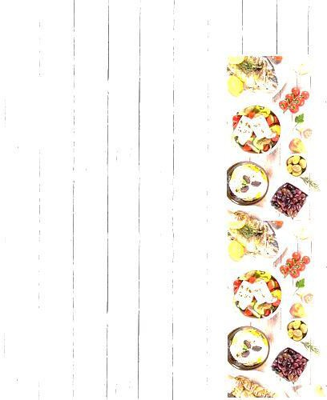

- 5 -

# SOUP

### BUFFET SUGGESTIONS

###### Vegetarian

Cream of Tomato Minestrone

Burnt Garlic Bean Curd Sweet Corn

Hot 'N' Sour

Spicy Lemon Coriander Manchow Mulligatawny

Shorba - E – Tamatar Dal Shorba

Palak Shorba

Tamatar aur Dhaniya Shorba Tomato Rasam

###### Non-Vegetarian

Cream of Chicken Sweet Corn Chicken Hot 'N' Sour Chicken Chicken Clear

Spicy Lemon Coriander Chicken Chicken Manchow

Chicken Talumein Soup

### VEGETARIAN MAIN COURSE

#### BUFFET SUGGESTIONS



###### Dry Preparation

Subz Degh Methi Paneer

Vegetable Makhanwala Subz Nizami Handi Bhendi Peanut Fry Bhindi Kurkure

Aloo Gobhi Adraki Punjabi Dum Aloo Vegetable Jalfrezi Subz Chatpata

Tawa Vegetable Masala Kadai Vegetables

Aloo Mutter Hara-pyaz Vegetable Tahiti

Chow Chow Vegetable Stir Fried Oriental Greens Schezwan Vegetables Bagara Baingan

Kaddu Ke Dalcha

###### Semi Gravy

English Vegetable Napolitaine Subz Makhanwala

Mili-julli Subji Millouni Bahar Nizami Handi

- 6 -



- 7 -



Capsicum Corn Masala Baked Corn and Spinach Beans Poriyal

Aloo Gobhi Tamatar Curry Guthivankaya Masala

Mix Vegetable Kurma Dondakaya Masala Vegetable Chettinad Vegetable Kolhapuri

###### Paneer

Kadai Paneer Paneer Makhani

Paneer Methi Chaman Paneer Do Pyaza Paneer Butter Masala Palak Paneer

Mutter Paneer Paneer Malai Kofta Paneer Kalimirch Chatpata Paneer Paneer Jalfrezi

#### NON-VEGETARIAN MAIN COURSE BUFFET SUGGESTIONS

###### Chicken

Hyderabadi Chicken Dum Biryani Hunan Chicken Fried Rice Andhra Chicken Pulao

Andhra Chicken Curry Butter Chicken

Murgh Do Pyaza Kadai Chicken Murgh Lababdaar Chilli Chicken Gravy Andhra Kodi Kura Murgh Kalimirch Patiyala Murgh Murgh Tariwala

Chicken Manchurian Gravy Guntur Chicken Curry

###### Fish

Fish Masala Mahi Anardana

Lemon Corriander Fish Hunan Fish

Fish Manchurian Nellore Chapala Curry Malabar Fish Curry Sarson Fish Masala Macher Jhol

- 8 -

## LENTIL AND RICE

#### BUFFET SUGGESTIONS



###### Lentil Preparation

Lashooni Yellow Dal Dal Makhani

Dal Tadka

Moong Dal Tadka Methi Dal

Palak Dal Sorakaya Pappu Tothakura Pappu Tomato Dal Rajma Masala Dal Maharani Dal Panchmel Khatti Dal Sambhar

###### Rice Preparation

Steamed Rice Vegetable Biryani Kashmiri Pulao Green Peas Pulao Vegetable Biryani

Cashewnut and Peas Pulao Jeera Pulao

Chilli Garlic Rice

Ginger Flavoured Fried Rice Schezwan Fried Rice Andhra Vegetable Pulao Coconut Rice

Lemon Rice Tamatar Rice

- 9 -



## INDIAN BREAD & CURD

#### BUFFET SUGGESTIONS

###### Indian Bread

Naan Tandoori Roti Roomali Roti

Laccha Parantha

###### Curd Preparation

Plain Curd Curd Rice Bhurrani Raitha

Cucumber Raitha Boondi Raitha Fried Papad

Roasted Punjabi Papad Fried Vodiyams

###### Accompaniments

Tomato Chutney Beerakai Chutney Vankaya Chutney Dosakaya Chutney Mango Pickle Gongura Pickle Mixed Pickle Gongura Chutney Beetroot Chutney

- 10 -



# DESSERT

#### BUFFET SUGGESTIONS

##### Western Selection

Tiramisu Fruit Triffle

Caramel Custard Gateaux

Chocolate Nut Brownie Cream Caramel

Bread Butter Puddings (Hot) Mud Cake

Mousse (Orange/ Kiwi/ Chocolate/ Vanilla/ Mint) Fruit Salad

Ice Cream Flavours (Vanilla/ Chocolate/ Strawberry)

##### Indian Selection

Double Ka Meetha Gulab Jamun Khubani Ka Meetha Gajar Ka Halwa Moong Dal Halwa Lauki Halwa Semiya Kheer

Rice Payasam Jalebi

Kala Jamun Phirni

- 11 -



- 12 -

@ ADDITIONAL COST

#### SUGGESTIONS

##### Lamb Preparation (@Rs.170++ per person)

Kadai Gosht Gosht Roganjosh Lal Maans

Gosht Do Pyza Mutton Masala

Andhra Mutton Masala

##### Live Counter || Chef @ Work

Dosa/ Uttapam (Rs.165++ per person)

Jalebi

(Rs.175++ per person)

Pasta

(Rs.175++ per person)